Name:

Date:

Period:

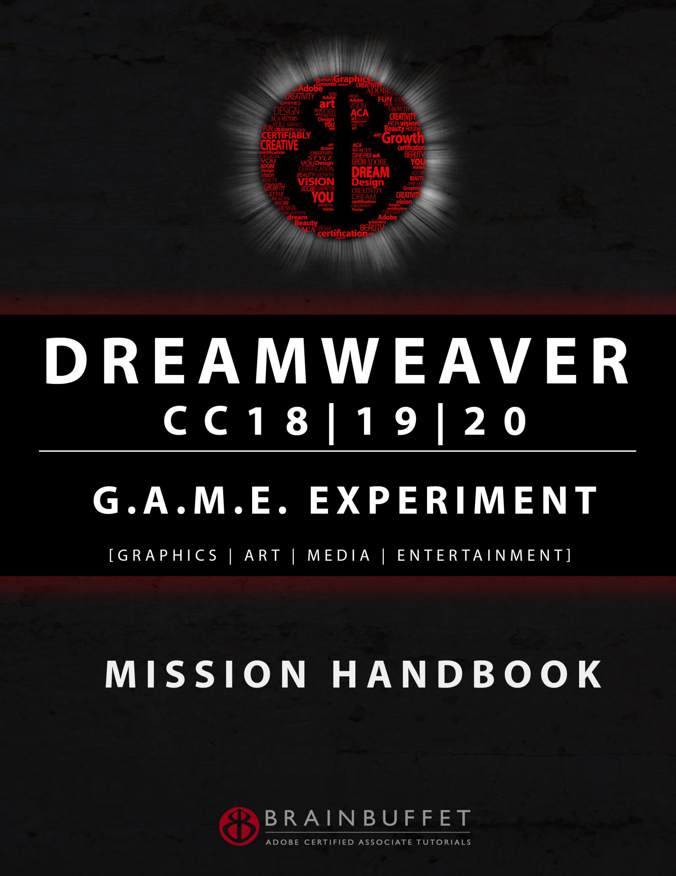

_____

[Year]

BrainBuffet Dreamweaver CC18|19|20 Student Packet

[DOCUMENT SUBTITLE]

CC LICENSE BY-NC-SA

 **DREAMWEAVER CC18|19|20 GAMER MISSION HANDBOOK**

Freely use and copy this unmodified workbook with this footer intact. Videos at brainbuffet.com

**Page 1**

Name: ________________________________________________________ Date: _____________ Period: _________

**DREAMWEAVER CC18|19|20 GAMER MISSION HANDBOOK**

Freely use and copy this unmodified workbook with this footer intact. Videos at brainbuffet.com

**Page 4**

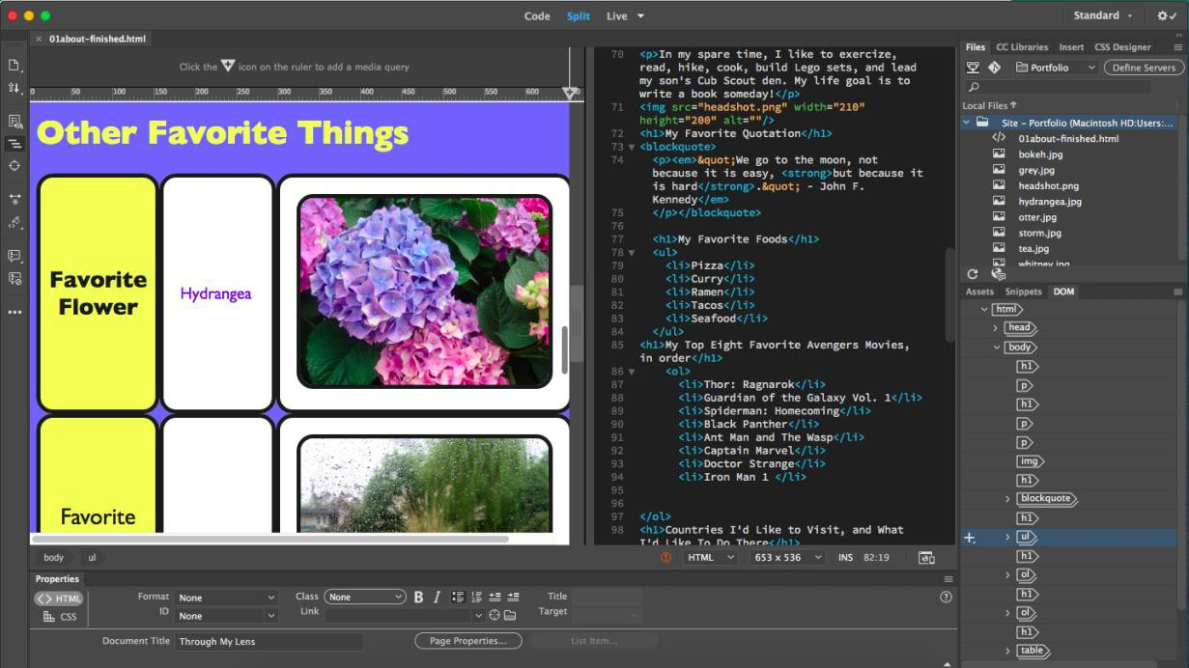

**Project 1 – Intro to HTML and CSS**

**Dreamweaver CC18|19|20 Project 1**

CheckmarkCloseCheckmarkClose

# A screenshot of a cell phone Description automatically generatedDreamweaver CC18|19|20 Project 1 S.E.T.

**cenario:** *Instagram, Facebook, and WordPress are great for the sheep who like their webpages to look just like everybody else. Do you want to be a sheep?*

**S**

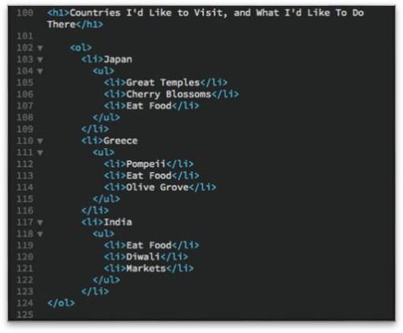*No way! Break free from the herd and learn to design your own custom web content. Learning to code isn’t very hard, but luckily Adobe Dreamweaver is more than just a coding platform. In this project, you’ll be introduced to the Dreamweaver interface, which will help you create and organize HTML and CSS code to design your own custom webpage.*

**xpectations:** Create a “social media profile” page to share info about yourself, like a bio statement, hobbies, and interests.

**E**

**imeline**: This should take you 4-5 hours of class time to complete.

**T**

|  |  |
| --- | --- |
| **Make sure to finish your BrainBuffet P.L.A.T.E.** for every day you’re working on a tutorial!  (Progress Learning, Activity, Timestamp, Experience.) | |
| **Day 1 Date:** | **Day 2 Date:** |
| Videos Completed: 1.01-1.04  Screenshots to document progress? What was the coolest thing you learned?  I learned how to properly set things up as headers | Videos Completed: 1.05-1.08  Screenshots to document progress? What was the coolest thing you learned?  I learned how to link emails and phone numbers as well as insert tables |

CheckmarkCloseCheckmarkCloseCheckmarkCloseCheckmarkClose

|  |  |
| --- | --- |
| **Make sure to finish your BrainBuffet P.L.A.T.E.** for every day you’re working on a tutorial!  (Progress, Learning, Activity, Timestamp, Experience.) | |
| **Day 3 Date:** | **Day 4 Date:** |
| Videos Completed: 1.09-1.12  Screenshots to document progress? What was the coolest thing you learned?  I learned how to style body and texts | Videos Completed: 1.13-1.14  Screenshots to document progress? What was the coolest thing you learned?  I learned how to style tables and lists |
| **Day 5 Date:** | **Day 6 Date:** |
| Videos Completed:  Screenshots to document progress? What was the coolest thing you learned? | Videos Completed:  Screenshots to document progress? What was the coolest thing you learned? |

# Dreamweaver CC18|19|20 Project 1 Worksheets

**NOTES: Using the BrainBuffet Project 1 tutorials, please answer the following questions. Key vocabulary terms are in *bold!***

1. Extend each line to match the screen shot to the **view mode** that describes the layout. (1.02)

|  |  |  |  |
| --- | --- | --- | --- |
| **Code View** | **Live View** | **Split View > Horizontal** | **Split View > Vertical** |
| ../../../Screen%20Shot%202020-06-02%20at%2011.10.45%20AM.png | ../../../Screen%20Shot%202020-06-02%20at%2011.11.17%20AM.png | ../../../Screen%20Shot%202020-06-02%20at%2011.10.34%20AM.png | ../../../Screen%20Shot%202020-06-02%20at%2011.10.52%20AM.png |

1. In what menu can you change the screen layout to horizontal/vertical, or move the code panel to the left/right/top/bottom? (1.02)
2. Give a definition for each HTML tag below. In the column on the right, give the closing tag that matches. (1.03)

|  |  |  |
| --- | --- | --- |
| **Tag** | **Definition** | **Closing tag** |
| **<doctype>** |  |  |
| **<html>** |  |  |
| **<head>** |  |  |
| **<body>** |  |  |

1. Give a definition for each HTML tag below. (1.04)

|  |  |
| --- | --- |
| **Tag** | **Definition** |
| **<p>** |  |
| **<h1>** |  |
| **<h6>** |  |
| **<blockquote>** |  |
| **<em>** |  |
| **<strong>** |  |

1. What is a **nested tag**? What order should nested tags be closed in? (1.04)
2. Look at the code below. Complete the closing tags in the correct order. (1.04)

<h1><em><strong>This is my header text!< > < > < >

1. What is a **root folder**? (1.05)
2. Explain what each of the 4 **Creative Commons** restrictions means. Insert a screen shot of the icon that represents that restriction. (1.05)

|  |  |  |
| --- | --- | --- |
| **Restriction** | **Icon** | **Definition** |
| **Attribution** | ../Desktop/Screen%20Shot%202020-06-04%20at%202.24.42%20PM.png |  |
| **Share Alike** |  |  |
| **Non Commercial** |  |  |

|  |  |  |
| --- | --- | --- |
| **No Derivatives** |  |  |

1. What are the four image file types that are supported by web browsers? (1.05)
2. Annotate the following lists with the correct tags. (1.06)

|  |  |  |
| --- | --- | --- |
| **Unordered List** | **Ordered List** | **Nested List** |
| < >  < >Item< >  < >Item< >  < >Item< >  < > | < >  < >Item #1< >  < >Item #2< >  < >Item #3< >  < > | < >  < >Item #1< >  < >  < >Sub-Item< >  < >Sub-Item< >  < >Sub-Item< >  < >  < >Item #2< >  < >Item #3< >  < > |

1. Annotate the code for the table below with the correct tags. (1.07)

< >

< >

< > First Row, First Cell < >

< > First Row, Second Cell< >

< >

< >

< > Second Row, First Cell < >

< > Second Row, Second Cell< >

< >

< >

1. Fill in the blanks to complete the hyperlink tags below. (1.08)

< = [http://www.url.com](http://www.url.com/) > Click here to go to the page < >

< = “ [email@certiport.com](mailto:email@certiport.com)”> Click here to email me < >

< = “ 308-555-1234”> Click here to call me < >

1. What does it mean when you see **file:///** in front of an image’s source location, and

how do you fix it? (1.09)

1. In what three locations can you insert an image into your webpage (other than typing the <img> tag by hand?) (1.09)
2. When you have an image selected in the Properties panel, what happens when you

click the check mark next to the image’s dimensions? (1.09)

1. Explain what **hotlinking** is, and why it is not a good professional practice in the web design industry. (1.10)
2. Complete the code for the CSS rule below with the missing syntax elements (1.11)

body

background-color black

font-family sans-serif

1. What are two tips to remember when choosing fonts and colors for the text on your

webpage to make them easy to read? (1.11)

1. Identify each of the **hexadecimal** color values below. (1.12)

#FFFFFF = white #FF0000 = #00FF00 =

#000000 = #0000FF =

1. Identify each of the **RGB** color values below. (1.12)

rgb(255, 255, 255) = white

rgb(255, 0, 0) =

rgb(0, 255, 0) =

rgb(0, 0, 0) =

rgb(0, 0, 255) =

1. Add a **tag selector** to make the rule below target both ordered and unordered lists. (1.13)

{ background-color: black; color: blue;

}

1. What CSS property allows you to remove or change the bullet point on a list? (1.13)
2. Define each tag needed to create a table. (1.07, 1.13)

|  |  |
| --- | --- |
| **Tag** | **Definition** |
| **<table>** |  |
| **<tr>** |  |
| **<td>** |  |
| **<th>** |  |

1. Complete the CSS rule below to style your hyperlinks to be white with no underlines. (1.14)

{

: # ;

: ;

}

1. How do you preview what your webpage will look like using a real browser that you have installed on your computer, such as Chrome or Firefox? (1.14)

# Dreamweaver CC18|19|20 Project 1 Checklist and Rubric

|  |  |
| --- | --- |
| **PROJECT 1 SPECIFICATIONS** | |
| **Create an HTML Page describing yourself that includes the following elements:**   * A bio paragraph with a photo (the photo can be of yourself, or it can be generic like a photo of your dog or favorite sports team logo) * A favorite quotation, formatted with blockquotes * 3 lists – a bulleted list, a numbered list, and a nested list that includes both bullets and numbers * A table listing your favorite things with a header row and at least 4 content rows. Each row should contain an image and a hyperlink. * A Contact section that contains a *fake* email and telephone link. Do not give out your personal information online! * manage your site folder by naming images and folders properly and keeping links organized. * Use CSS to style the elements of your page in a visually attractive manner that represents your personality and interests. | **Site folder should have:**  /my_portfolio   * about.html * profile picture * 6-8 images of your favorite things   **You should be able to:**   * Open different panels in Dreamweaver * Use the Properties, Insert, and CSS Designer panels * Know the basic HTML text tags to create paragraphs, headings, lists, tables, and hyperlinks. * Insert and resize images. * Style HTML tags using CSS rules. * Save an HTML page in Dreamweaver. * Choose copyright-free images for a website. * Preview an HTML page using a live browser. |

|  |  |  |
| --- | --- | --- |
| **Dreamweaver Project 1“All About Me” Scoring Rubric** | | |
| ***Areas of Improvement*** | ***Criteria*** | **Evidence of Exceeding**  **Standards**  *Your teacher can provide feedback in this column to point out areas where you have demonstrated skill that goes above and beyond the basic criteria. Extra*  *Credit may be awarded.* |
| *Your teacher can provide feedback in* | *The basic requirements of the project are listed* |
| *this column to show you areas in your* | *in this column. If you meet these criteria, you are* |
| *skills that need improvement. Points may* | *right on track! Great job!* |
| *be deducted by your teacher from this* |  |
| *column.* |  |
|  | ***Page Content – 10 points***  Your page contains a biography, “profile picture,” favorite quotation, three lists, a table that identifies your favorite things with hyperlinks and images, and a Contact section. |  |
|  | ***HTML and CSS Structure – 10 points***  The structure of your HTML tags and CSS rules displays correctly without any errors. Your code is written cleanly with spacing and indentation as appropriate. |  |
|  | ***Correct Images and Hyperlinks***  ***– 10 points***  All images display correctly, and all hyperlinks work. Images are appropriately sized within your page content with acceptable resolution. |  |
|  | ***File Management – 10 points*** All files (pages and images) and folders are named meaningfully and according to best practice (camelCase or hyphens, no spaces).  Files and folders are organized in an easy to understand manner. |  |
|  | ***Creativity and Design – 10 points***  The visual and design elements of your page create a pleasing, professional finished product. |  |
| **Total Score:** | | |

**Dreamweaver CC18|19|20 Project 1 Extension Projects**

## Project 1 Extension Challenges:

* Add additional sections to your “About Me” page, such as an image gallery, or

question and answer section.

* Work on a free online course in HTML and CSS from Codecademy.com

## Project 1 Cross-Curricular Enrichment:

Create an “About Me” social media page for a person from any curricular area – an author, mathematician, historical figure, scientist, inventor, or fictional character.